Name:_________________________
 | Directions | Symbol
1 | Move one Square Right
2 | Fill Square | 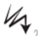
3
4
5

MHS Enrichment Coding Continuum – Unplugged Activity #1
Finish the directions
Write the algorithm for the following:
*Always begin in square with star
*
Options:
Move One Square Left
Move One Square Right
Move One Square Down
Move One Square Up
Fill Square.
Solution:

Move one square right.
Fill in square.
Move one square down.
Move one square right.
Fill in square.

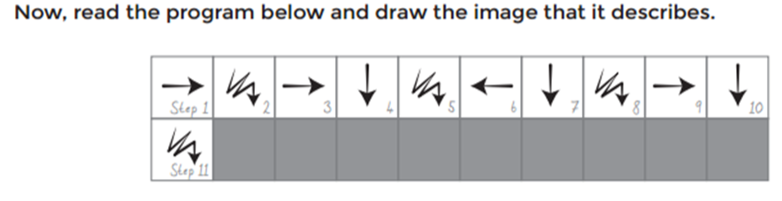
Start Here

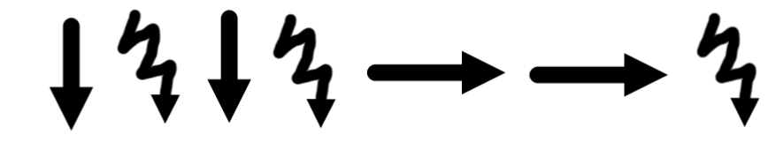
Hint: Always start at the STAR, be sure to shade in the full square.
Start Here
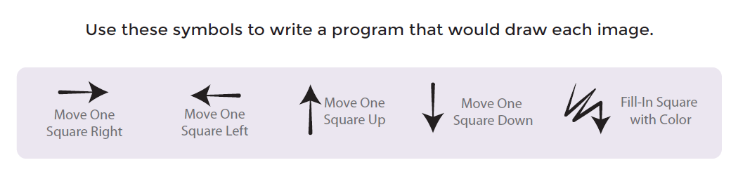
*Always begin in square with star

Step 1 | Step 2 | Step 3 | Step 4 | Step 5 | Step 6 | Step 7 | Step 8 | Step 9 | Step 10
Step 11 | Step 12 | Step 13 | Step 14 | Step 15 | Step 16 | Step 17 | Step 18 | Step 19 | Step 20

*

Now you fill in 3 random squares and write the
program that would draw the image.
*Always begin in square with star
Step 1 | Step 2 | Step 3 | Step 4 | Step 5 | Step 6 | Step 7 | Step 8 | Step 9 | Step 10
Step 11 | Step 12 | Step 13 | Step 14 | Step 15 | Step 16 | Step 17 | Step 18 | Step 19 | Step 20

*

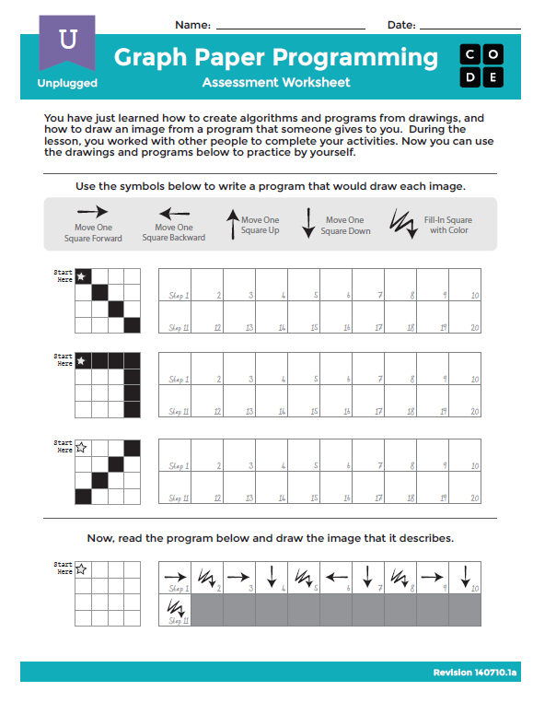
Reminder: You must get your Contiuum Card initialed by a teacher before going to next level!

